## Laboratory work 1

Data Base : SQL 2017 server configuration

**Prerequisites: Device with internet connection, patience**

**Objectives: Setup and Understanding of basic MS SQL Server features**

**Tasks: Download, install, feature checking, connection establishment, service initialization, server registration, user creation and assignment, roles management**

**Implementation:**  
**Configuration management. Initial services working well, nothing changed.**

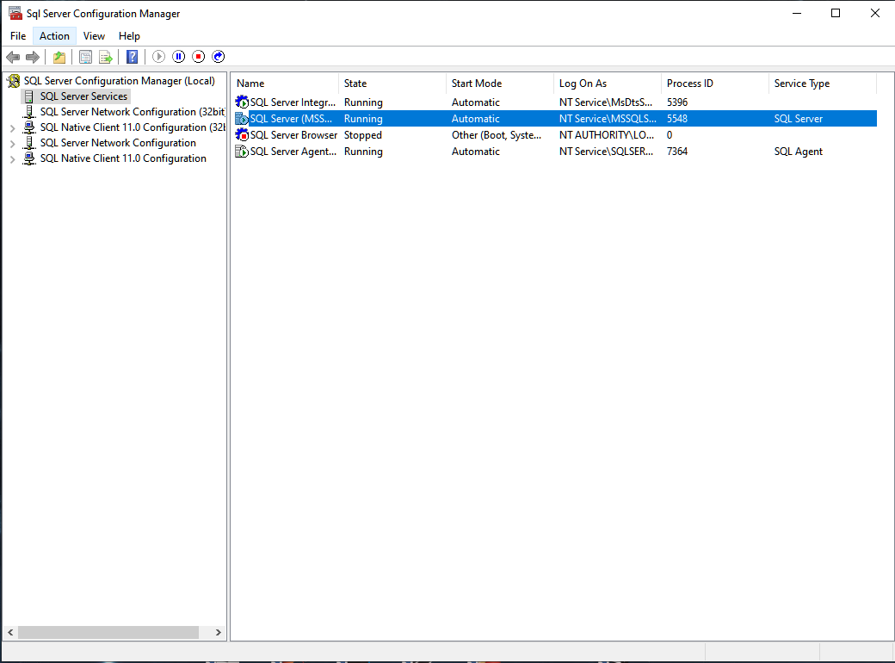

All 3 logins have different roles and mappings, thus they have different levels of access to the data which will be stored in the future.

**Answers to the Questions:**

1. What are the advantages of using client-server technology to administrate databases?

One of the main advantages of using client-server technology to administrate databases is that there can be a few users that are working simultaneously on the same database. They can access corporate information through a desktop interface. Due to the fact that the flow of data is handled by more servers, there are no traffic retentions or slowing downs.

2. What would the minimal hardware resources required for working with the SQL Server 2017?

The hardware resources required are different from one edition to another.

* For the Windows OS, it is estimated that a minimum of 512 Mb RAM memory is necessary (for running the Express Edition), while 1Gb would be preferred;
* At least 6 Gb Hard Disk memory is required for running the SQL Server 2017 RDBMS. The minimal frequency at which the program can run is 1.4 GHz on a x64 processor;
* Concerning the Drive Disk, a DVD ROM Drive is what it takes for an installation from the optical disk;
* Finally, it is recommended using a desktop with Super-VGA 800x600 desktop resolution at minimum.

3. What are the authentication types provided within the SQL Server 2017?

The authentication is hybrid since users can log via SQL Username or Windows User Auth.

## Conclusion

The installation process and setup of MS SQL Server 2017 is complex because it must be configured according to a lot of features. The setup of SQL Database requires documentation and tutorials as it is also not very easy. The authentication phase can be hybrid, due to the fact that users can login via SQL Username or Windows User Auth.